Welcome!
Date
Name
Spouse
Address
City
State Zip _________
Email

Please Contact By
❑ Card  Phone  Visit

Telephone Best Time to Call
Home ______________
Work ______________

Guest: First Time Second Time
Are you a church member: yes no
Church
City, State

Circle Appropriate Age/Grade Group(s)
Preschool: Ages: B-1 2-3 4-5
Children: Grades: K 1 2 3 4 5 6
Youth: Grades: 7 8 9 10 11 12
Adults: Ages:18-29 30s 40s 50s 60s+

How did you learn about our church?
Newspaper Friend Yellow Pages Mail
Other

I am a guest of:

New in the Community? Yes No
Names & ages of children at home

Weekly Service & Activity Schedule

June 18, 2017

9:45 a.m. Sunday School
11:00 a.m. Worship Service
No Evening Service

Week of June 18, 2017
Wednesday 6:30 pm………………..…Meal/Bible Study
Thursday 10:00 am……………….….Adult Fellowship
Friday 6:30 pm……………..……………..Men’s 42 Night
June
22……………………………………………Adult Fellowship
22……………………….………Make and Take Card Class
25………………………………..…………Business Meeting
July
2…………………………..……..Smothermon Baby Shower
6……………………………………………..Adult Fellowship
9…………………………………..New Commandment Kids
9……………………………………….………..Lord’s Supper
Make & Take Card Class with a 4th of July Theme

Thursday, June 22, 6pm – 9pm in the Fellowship Hall

The cost is $20 and attendees will take home 4 cards. Contact Brenda Williams if you are interested.
512-925-8572

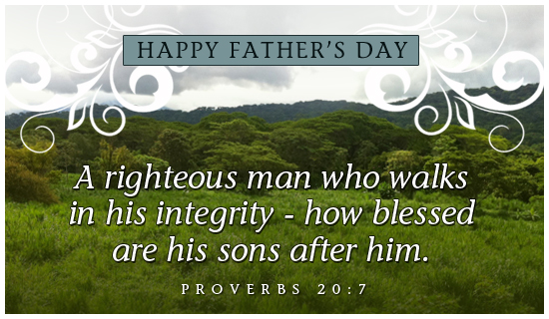

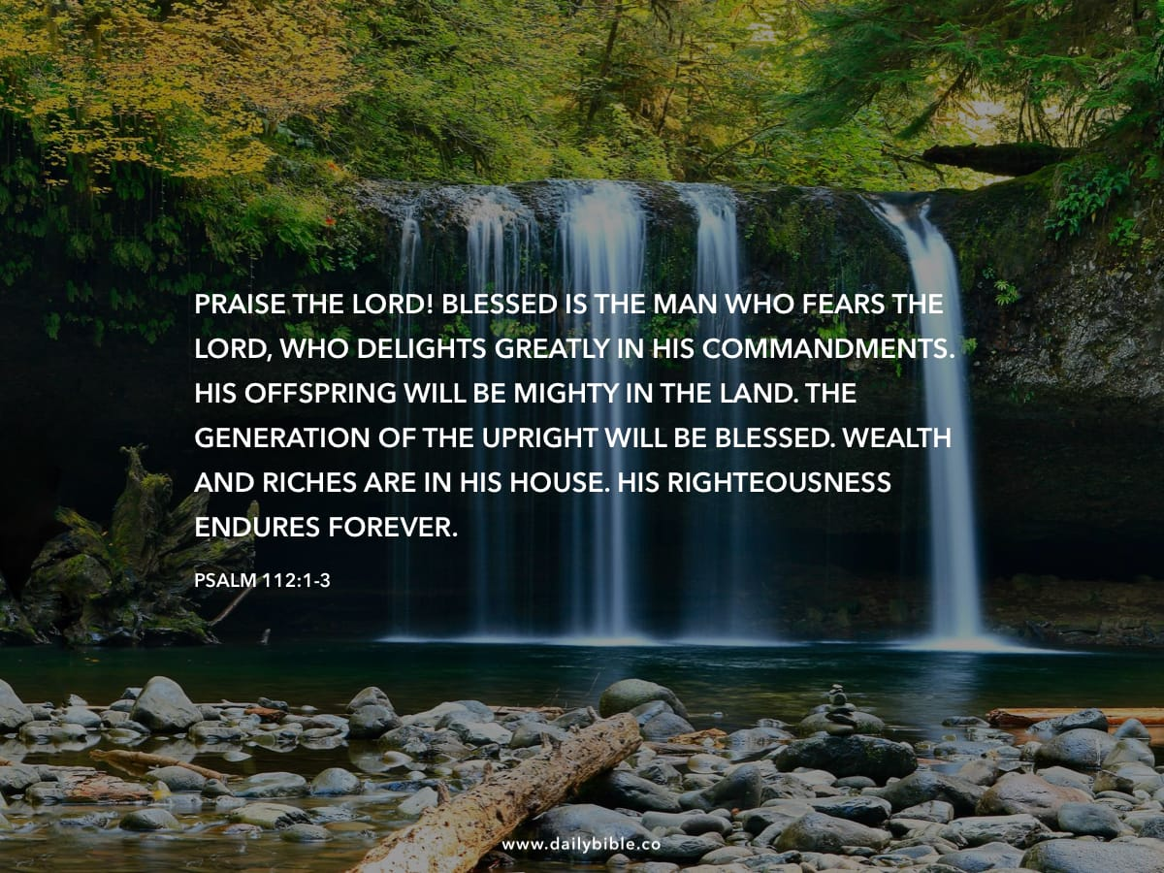

Knobbs Springs Baptist Church

June 18, 2017

Church Information:

KnobbsSpringsBC.com KnobbsSpringsBaptist@gmail.com

1662 CR 305, McDade, Texas 78650 512-273-2743

David Atwood, Pastor Cell 512-470-5098

Patti Radford, Office Manager Cell 512-968-7821

